004 BUS SYSTEM
Data from Voltage Stability of Electric Power System( Paper 89 example. Van Cumsyt. Cutsem)
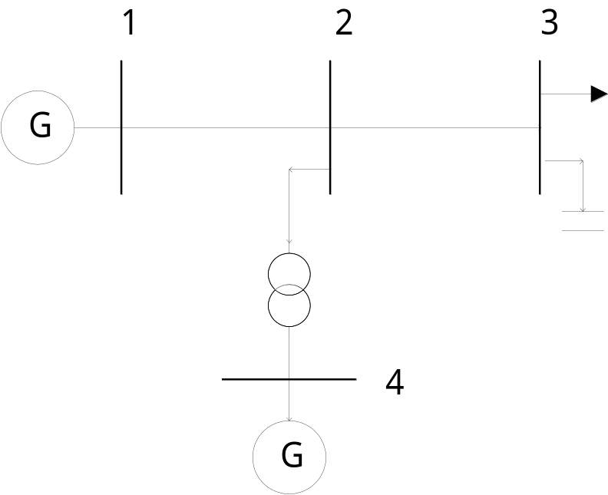 Diagram by Lei SHI 2000.4.13
BPA DATA:
(POWERFLOW,CASEID=EMS,PROJECT=TEST)
/P_INPUT_LIST,FULL\
/P_OUTPUT_LIST,FULL\
/P_ANALYSIS_RPT,LEVEL=4\
/TOLERANCE,AIPOWER=0.0001,Q=0.0001\
/SOL_ITER,DECOUPLED=4,CURRENT=0,NEWTON=30\
/NETWORK_DATA\
.234567890*234567890*234567890*234567890*234567890*234567890*234567890*234567890
BS bus_1 100 1 200. 99990-99991080
B bus_2 100 1
B bus_3 100 1300. 100. 50.
BQ bus_4 100 1 100. 99990-99991050
-999
.234567890*234567890*234567890*234567890*234567890*234567890*234567890*234567890
.234567890*234567890*234567890*234567890*234567890*234567890*234567890*234567890
L bus_2 100 bus_1 1001 .2
L bus_3 100 bus_2 1001 .05
L bus_4 100 bus_2 1001 .03
.234567890*234567890*234567890*234567890*234567890*234567890*234567890*234567890
(END)

